Shabbos Stories for
Parshas vayikra 5781
Volume 13, Issue 30 7 Nisan/March 20, 2021
Printed L’illuy nishmas Nechama bas R’ Noach, a”h

For a free subscription, please forward your request to keren18@juno.com
Past stories can be found on the website ShabbosStories.com
David Mintz, Whose Tofutti Made Bean Curd Cool, Dies at 89
By Sam Roberts

He set out to create an ice cream substitute for people who keep kosher. He created a phenomenon, also loved by vegans, diabetics and people with milk allergies.

Mr. Mintz in 2013. After production of Tofutti zoomed, the company went public and succeeded beyond even Mr. Mintz’s vivid imagination. Photo Credit...Julio Cortez/Associated Press

The rise of David Mintz from Brooklyn caterer to the multimillionaire who became known as the “P.T. Barnum of tofu” began with a grandmother — not his own, but a 90-year-old woman who happened to walk into his prepared-food takeout grocery one day and apply for a job as a cook.
Her homemade noodle kugel became such a neighborhood hit that from then on he hired only grandmothers as cooks — a babushka marketing brainchild that proved so successful, he opened a restaurant on the East Side of Manhattan, near Bloomingdale’s.
His meal offerings, including prepared takeout dinners and catering, were strictly kosher; most of Mr. Mintz’s customers were observant Jews whose faith forbade mixing meat and milk. If they craved ice cream after dinner, for instance, they would have to buy a version made without milk.

What another restaurateur might have lamented as his just deserts, Mr. Mintz accepted as a challenge to develop a pareve, or nondairy, crossover substitute.
It took several years, and he gained 50 pounds. He began his research by buying a carton of soy milk in Chinatown, and he poured gallons of unappetizing gelatinous white concoctions down the drain of his kitchen in the Bensonhurst section of Brooklyn.
“I am personally responsible for clogging the sewers of New York City,” he told Forbes magazine in 1984.

Tofutti became known as the first commercial tofu ice cream. One writer said it made “a delicious and refreshing dessert that is the rival of many commercial brands of ice cream.” Photo Credit...via Tofutti

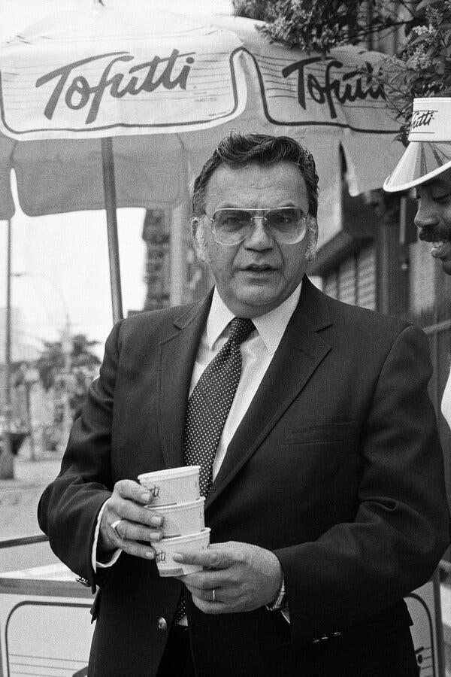
David Mintz, chairman and chief executive of Tofutti Brands, in 1984. His company went from distributing pint containers of its signature frozen vanilla soy-based dessert to developing some 35 plant-based products. Photo Credit...Sara Krulwich/The New York Times

Finally, in about 1981, Mr. Mintz tasted victory by incorporating tofu into his recipe.
Tofu, the curds of coagulated soy milk pressed into spongy white blocks, is fairly tasteless, so it can be transformed into savory flavors that appeal to people who keep kosher, or who are allergic to dairy or otherwise can’t tolerate it. It’s also commonly eaten by people who are diabetic or vegan, or who are dieting to reduce their cholesterol.
His creation, which he called Tofutti, consisted of tofu emulsified with vegetable oil and mixed with alfalfa honey and other ingredients, which together took on a butter-fatty texture. Thanks to his flair for promotion and marketing, it became widely known as the first commercial tofu ice cream.
“I like a pineapple-sweet potato Tofutti,” Mr. Mintz told The New York Times in 1984, “but the public may not be ready. I like the idea of mango, and I love hazelnuts, and watermelon is one of my favorites. I absolutely love garlic, but I don’t suppose. …”
He died on Feb. 24 at a hospital in Englewood, N.J., near his home in Tenafly, said Rabbi Efraim Mintz, a nephew. He was 89.
David Mintz was the chairman and chief executive of Tofutti Brands of Cranford, N.J., which expanded from distributing pint containers of its signature frozen vanilla soy-based dessert to developing some 35 plant-based products. Among them are pizza, ravioli and Mintz’s Blintzes, all made with milk-free cheeses.

Promising Early Reviews…Drove Demand
Promising early reviews, coupled with promotional materials that defined tofu, drove demand.
“Mintz’s soyburgers evoke instant associations with potato pancakes,” Lorna J. Sass, a vegan cookbook author, wrote in The Times in 1981, “and his rugelach have the right cinnamon-raisin-nut balance to make their creation out of a flaky tofu-whole wheat crust seem downright remarkable.”
“His vanilla Tofutti ‘ice cream,’” she added, “makes a delicious and refreshing dessert that is the rival of many commercial brands of ice cream.”
Mr. Mintz distributed samples and drew orders from Zabar’s, Bloomingdale’s and other stores. Production zoomed from tiny batches in kettles to 10,000 gallons a week. The company went public, and Tofutti succeeded beyond even Mr. Mintz’s vivid imagination.
Donald Isaac Mintz was born on June 8, 1931, in the Williamsburg section of Brooklyn to Abraham Mintz, a baker, and Sadie (Horowitz) Mintz, a homemaker. (Legend has it that his mother, who spoke little English, reported his name as Dovid, Yiddish for David, but the nurse who filled out his birth certificate misunderstood — and thought he looked more like a Donald.)
After graduating from a Lubavitcher Yeshiva high school in Crown Heights, he attended Brooklyn College, briefly sold mink stoles, and ran a bungalow colony in the Catskills, where he opened a deli.
It was after he opened his Manhattan restaurant, he said in one of many versions of the story, that “a Jewish hippie” tipped him to the potential of tofu. “The Book of Tofu” (1979), by William Shurtleff and Akiko Aoyagi, became his new bible.
Mr. Mintz’s first marriage ended in divorce (“Bean curd wasn’t exciting to her,” he told The Baltimore Jewish Times in 1984). In 1984 he married Rachel Avalagon, who died this year. He is survived by their son, Ethan.

Guidance from the Lubavitcher Rebbe
Mr. Mintz often sought guidance from Rabbi Menachem Mendel Schneerson, the venerable leader of the Lubavitcher Hasidic movement, to whom he had been introduced by his brother, Isaac Gershon Mintz. David Mintz would write daily $1,000 checks to Rabbi Schneerson’s philanthropies, according to COLLive, an Orthodox news site. (He was a founder of the congregation Chabad of Tenafly.)
“Whenever I met with the rebbe I would mention what I was doing, and he would say to me: ‘You have to have faith. If you have faith in G-d, you can do wonders,’” Mr. Mintz said in an interview with Jewish Educational Media in 2013.
Late in the 1970s he had to close Mintz’s Buffet, his restaurant on Third Avenue, because the block was being razed to build Trump Plaza. When he was offered the option to transplant his restaurant to the Upper West Side, he sought Rabbi Schneerson’s guidance. The rabbi’s secretary, Rabbi Leibel Groner, called him back, Mr. Mintz recalled, and said: “Get a pencil and paper and write it down. This is very important.”
“I was very excited,” Mr. Mintz said. “This was the answer I was waiting for. Then he dictated to me, ‘The rebbe says, “Absolutely not.” The rebbe says you should continue with your experiments with the pareve ice cream and G-d will help you to be very successful.’”
Mr. Mintz kept the formula for his success a secret between him and his production manager. “If you take all the ingredients and try to make Tofutti,” he told Money magazine in 1984, “you’ll never do it.”

Sam Roberts, an obituaries reporter, was previously The Times’s urban affairs correspondent and is the host of “The New York Times Close Up,” a weekly news and interview program on CUNY-TV. @samrob12
Reprinted in the March 5, 2021 website of The New York Times. A version of this article appears in print on March 7, 2021, Section A, Page 27 of the New York edition with the headline: David Mintz, 89, Whose Tofutti Made Bean Curd Cool.

The Rebbe Who
Did Not Praise
By Elchonon Isaacs

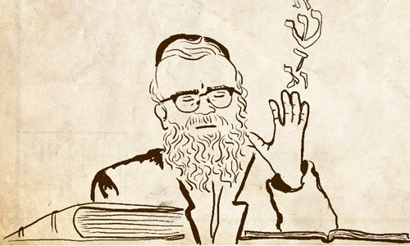

Rabbi Tarfon’s mother was walking in the yard on Shabbat and her sandal tore. Rabbi Tarfon placed his hands under her feet until she returned home.
Sometime later, Rabbi Tarfon fell ill and his colleagues came to visit. His mother asked them to pray for her son, mentioning that he was exceedingly careful with honoring her. The sages asked, “How so?” and she recounted the episode.
“Even if he’d do thousands of times more than that, he would not have reached half of his Torah obligation,” they responded.¹

Rabbi Avraham Borenstein of Sochaczew (1838-1910), son-in-law of the famed Rebbe of Kotzk, was known for his Talmudic commentary and responsa, as well as for his erudite lectures that drew large crowds to his yeshiva.
His lectures typically flowed freely, but on one occasion when teaching the passage about Rabbi Tarfon, he paused and sank deep into thought. After a few moments, he looked up, having clearly experienced an ‘aha’ moment.
Those present were intrigued and did not have to wait too long for an explanation.
Reb Avraham began by questioning the story. “How can such a thing be?” he asked. “A mother who is worried about her ill son turns to the sages with a request for prayer and recounts his merits. But not only do the sages not accept the praise, they outright reject it! Why would they disregard the mother’s words and the remarkable actions of her son?”
His enthusiasm grew and he began to sway back and forth. “Listen to the following story that happened to me,” he continued.
“When I was newly married and living with my in-laws in Kotzk, I fell ill to the point of no return. The family sent word to my father in Biala that he should come immediately.
“My father, of course, dropped everything and traveled to visit me. He was appalled to learn that my father-in-law, the Kotzker Rebbe, appeared impervious to my illness and had not visited even once. The conduct of my father-in-law, who was my father’s own Rebbe, bewildered and saddened him. He summoned up the courage and entered the Rebbe’s study and cried: ‘Rebbe! I gave you my dear son for your daughter, trusting that you would take care of him. Now I hear that you have not even visited him! Do you know that my son learns Torah 20 hours a day?”
“My father-in-law, the Rebbe, heard what my father said and retorted, ‘You call that learning?!’
“My father knew he was standing in the presence of a holy man and left the room broken-hearted. He did not breathe a word of the encounter to anyone.
“A few days later my condition improved, much faster than anticipated. After I fully recovered, my father told me about the odd exchange he had had with my father-in-law.
“For 40 years this episode has lived in my memory, and much as I tried I could not understand my father-in-law’s actions. How could it be? I was deathly ill. My father requested that his Rebbe pray for me, mentioning the merits of my assiduous study schedule, about which it is said,² “For with me shall your days increase, and they will add to you years of life.” And here, when I was in deep need of increased days, my father-in-law completely disregarded my impressive study schedule!
“Now, learning the story of Rabbi Tarfon and the reaction of the sages to his mother’s request, I have finally gained some clarity.
“Every soul is sent into thisEvery soul is sent into this world with something to rectify world with something to rectify. If they do not fulfill that mission, they are sent back as a reincarnation until the goal is reached.
“How can a person know what he or she is here to fix? When we see that a person is attracted to a particular mitzvah and fulfills it with zeal, we can assume that this is their mission.
“When Rabbi Tafon’s mother began praising her son’s diligence in honoring her, the sages understood that this mitzvah was the purpose of his life here on earth. They feared that maybe he had achieved his goal and thus his time to return to his Maker had arrived. They therefore told his mother that he had not yet fulfilled a fraction of his obligation, thereby effectively granting him more years to live.
“Likewise, when my father told the Rebbe of Kotzk about my study schedule, the Rebbe understood that Torah study is my main purpose in life, and perhaps because of my great study schedule I had already completed my mission and my time had come. My father-in-law therefore discounted the merit, asking, ‘You call this learning?!’
“With those few short words he made it clear that my time had not yet come and my recovery was imminent.”

FOOTNOTES
1. Jerusalem Talmud Peah 1:1. See also Kiddushin 31b and Tosafot there.
2. Proverbs 9:11.

Reprinted from the Parshat Vayakhel-Pekudei 5781 email of Chabad.Org Magazine.

Story #1213
The Last Shabbat in Yonkers
From the desk of Yerachmiel Tilles

In January 2021, one of my beloved congregants in Lincoln Park Jewish Center [in Yonkers, NY – see ed. note at end] told me [Rabbi Levi Welton] it would be his last Shabbat in shul.
"Sorry, Rabbi, but I got offered a job and I'll have to work on the Sabbath." He caught me off-guard as we both stood socially distant from one another, our masks covering our faces. He had been a rabbi's model congregant (and, by that, I mean he didn't fall asleep during my sermons) and I was just beginning to get to know him.
What was I supposed to tell him? That I'd love to see him whenever he can make it to shul? That there are many other mitzvahs he can do to bring Mashiach? The Corona virus has impacted so many people financially and they were offering him a lucrative salary. Who was I to mess around with someone else's parnossa (livelihood)?

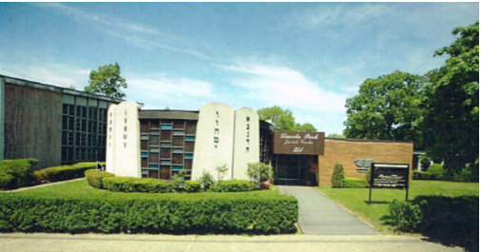
Lincoln Park Jewish Center in Yonkers, NY

For those who know me, you know that I hate conflict and often bend over backwards to accommodate and not alienate. But this wasn't some trivial Facebookdebate. This was the holy Shabbat we're talking about! I was on the spot. What was I supposed to do?

A Saying of Ahad Ha’am
"What would the [Lubavitcher[ Rebbe say?" This thought pierced my mind as I stood there, his eyes searching mine. I took a deep breath. "My brother," I began. "It is impossible that the Creator of Heaven and Earth would give a child of His a challenge he cannot overcome. A great Jewish poet - the Ahad Ha'am - once said, ‘More than the Jews have kept Shabbat, Shabbat has kept the Jews.’ You must tell them you can't work on the Shabbat. And, if you need a letter stating you require religious accommodation, I will write one for you."
During this past week, he did not reach out to me. I worried if he would ever talk to me again. "Maybe I shouldn't have pushed so hard?" Today, after I finished praying the Amidah, I turned around to face the congregation and saw him in the second row. He smiled and waved to me.
I snuck over to him and asked in shock, "What are you doing here?!"
He leaned close and said, "Rabbi, everyone else in my life was encouraging me to take the job. You were the only one who was adamantly opposed. Yet, in the end I turned it down. I thought to myself, if there are Holocaust survivors like R' Chaim Grossman who still show up to shul, then how much more so should I.
“So guess what happened next? When my old job heard what happened, they offered me a raise to stay. Plus, they put in my new contract that I will never have to work on Shabbat! I want you to know that if you hadn't given it to me straight, I wouldn't be standing here today."
I couldn't believe what I was hearing. Tears hit my eyes. In my sixteen years as a Rabbi, this is one of the top moments of my entire career. I opened my mouth and told him that the Talmud (Avodah Zarah 17a) states there are those who acquire their World to Come in (just) one glorious moment. As the service progressed, I couldn't control myself and I stood up in front of the entire congregation and, with his permission, told them what had occurred.
I said that the Talmud (Berachot 6a) teaches that G-d wears tefillin just as His children do. In our tefillin, it is written, "Hear O'Israel, the Lord our G-d, the L-rd is One" (Deut. 6:4). But, in His tefillin, it states, "And who is like your people Israel, a nation unique on Earth." (II Samuel 7:23).
This man inspired our entire congregation. This man inspired me. It's easy for me to come to shul on Shabbat. After all, I'm paid to do so. But, for someone like him, to make that choice....achh, all I can say is that we are now reading the stories in the Torah of the "miracles and signs" G-d made for the Jewish people in Egypt. But this was a great miracle this man made for G-d.

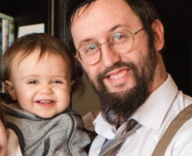
Rabbi Levi Welton

Source: Lightly edited and supplemented by Yerachmiel Tilles from a post by Rabbi Welton. Rabbi Levy Welton is an educator-turned-writer passionate about sharing the values of Torah with a global audience. Raised in the San Francisco Bay Area, he holds degrees in medicine, education, and film. Currently, he works as the spiritual leader of Lincoln Park Jewish Center in Yonkers, NY, and a healer for low-income patients in NYC. Additionally, he serves as a chaplain in the United States Air Force. For more info, visit //rabbiwelton.com Connection: Weekly Reading – the significance and sanctity of Shabbat observance (Ex. 31:12-17).
Editor’s note: My wife (maiden name: Lauterbach) grew up around the corner from Lincoln Park Jewish Center. Her father was a member and on the Board of Directors for decades. Several family celebrations were held there.

Reprinted from the Parshat Vayakhel-Pekudei 5781 email of KabbalaOnline.org, a project of Ascent of Safed.

An Unforgettable
Fire on Shabbos

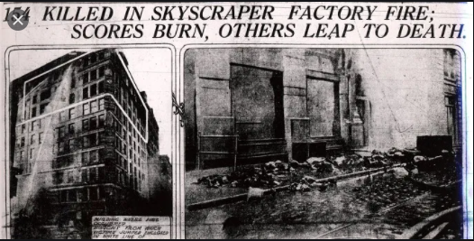

In 1911, a few years after her parents and five younger siblings had immigrated to America, 19-year-old Ida went job hunting. It was difficult to find a job that would allow a worker to keep Shabbos. The five-day work week would come decades later.
Now, many Jews were falling victim to the New World’s standards of forsaking Shabbos in order to put bread on one’s table. It was an agonizing challenge of the times. Ida’s parents had raised their children with the strong belief that the Torah was their guiding light, no matter what environment or country in which they lived.
Ida was tempted to accept a job at the Triangle Shirtwaist Company in New York, at which she could earn much needed overtime pay to fill orders from the backlog created by a recent strike. Ida resolutely declined the offer. The company required all workers to come in on Shabbos – without exception. Ida needed the money, but Shabbos to her was inviolate.
The next week, on Shabbos afternoon (March 25, 1911), a disastrous fire raged throughout the three floors that the Triangle Shirtwaist Company owned in a ten-story loft building. One hundred and forty-six people died, mostly young women, due to narrow congested aisles and locked doors which trapped in the workers. This fire prompted the setting of strict industrial safety codes and remedial factory legislation throughout the United States.
The Shabbos of the fire, in shuls throughout the world, the following pasuk was read in Parshas Vayakhel: “You shall not kindle fire in any of your dwellings on the Sabbath day” (Shmos 35:3). Today, Ida’s descendants gratefully and proudly commemorate her commitment to Shabbos observance, which saved her life, and thus granted them life as well. (Echoes of the Maggid by Rabbi Paysach Krohn)

Reprinted from the Parshas Vayakhel-Pekudei 5781 email of The Weekly Vort.

The Rabbi’s Delayed
Plane Flight

Rabbi David Ashear told a story in Living Emunah 3 about a rabbi who was challenged and waited to act. Rabbi Ezriel Tauber related that he was once invited to be the keynote speaker for a very large event. As he waited at the gate to board his flight from Israel, they announced the flight was going to be delayed four hours. The delay meant Rabbi Tauber would miss the event where he would have delivered the keynote address.
As soon as the announcement was made, the passengers began angrily complaining about how they were going to miss meetings, appointments, and other scheduled events. The people were in an uproar, frantically trying to switch flights. Rabbi Tauber, however, sat in his seat calmly, learning from a sefer, as if nothing had happened.
A Jewish professor who was on the same flight observed the crowd and took note of Rabbi Tauber’s conduct, noticing he sat without a reaction. The professor knew of the event scheduled and of the rabbi’s upcoming keynote address. He approached the rabbi and asked how he could remain so calm and exhibit no signs of agitation.

Rabbi Ezriel Tauber, zt”l

Rabbi Tauber explained that although he would be missing the opportunity to deliver such an important speech, the Torah teaches that Hashem is in full control. And if the flight delay was for the best, there was no need to become upset and distraught.
Fifteen years or so years later, the professor happened to meet Rabbi Tauber again and asked if he remembered him. The rabbi answered in the negative, and the professor reminded him of their exchange at the airport. The professor, who now wore a kippah and a beard, said, “That day, when I saw how you remained so calm at the airport, I was so inspired that I decided to explore Torah. I ended up becoming a baal teshuvah.”
Rabbi Tauber, visibly moved, said, “For years I was trying to figure out how missing an opportunity to give an inspirational speech to a large crowd could have been a good thing. I hadn’t found the answer until today. The delay resulted in my bringing another Jew back to Hashem.”
Because the Rabbi believed so fiercely that Hashem is in control, he didn’t get anxious or upset like B’nei Yisrael did in the six hours they waited for Moshe, and a fellow Jew found enough inspiration to return to Hashem.

Reprinted from the Parshat Ki Tissa 5781 email of Jack E. Rahmey as based on the Torah teachings of Rabbi Amram Sananes.

The Donation that
The Rabbi Rejected

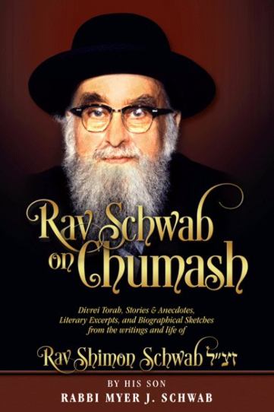

A man offered Rav Shimon Schwab, O”BM, a large donation. The Rav recalled that this man had previously declared bankruptcy, thereby avoiding paying his creditors. “Didn’t you declare bankruptcy a few years ago?” he asked. The man replied he did, and the Rav wanted to know what happened since then.
“Thank G-d, I went to bankruptcy court and received a settlement,” the man responded. “I was able to restructure my business, and today I am even wealthier that I was originally. I therefore wish to offer the Rav this large donation for his Yeshiva.”
“You must use the money you wish to donate to pay back your creditors,” the Rav answered. “According to the Shulchan Aruch, there is no such thing as declaring bankruptcy to free yourself from debt. When a man owes money, he is obligated to return it. Otherwise, he is considered a thief. Money that is to be given to Tzedaka must be earned in a Kosher manner. Bankruptcy is not kosher.” (Story from “Rav Schwab on Chumash”)

Reprinted from the Parshas Ki Sisa 5781 email of Torah Sweets Weekly as edited by Mendel Berlin.

